South Carolina High School Female Speed & Strength Meet

Saturday, February 27, 2016
AC Flora High School

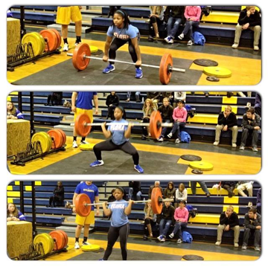
Events: Pro-Agility Shuttle, Clean, Squat, Bench Press
Entry: $10 per athlete: Awards for Top 3 in each weight class
Females will be divided into the following Weight Classes:
- Less than 110 lbs.
- 111-130 lbs.
- 131-150 lbs.
- 151-180 lbs.
- 180 lbs. and up
Registration due by: February 15th
Contact: Coach Kurtz or Coach Moore AC Flora High School to sign up
Email: KurtzMicah@gmail.com or patti.moore@richlandone.org

