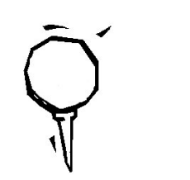
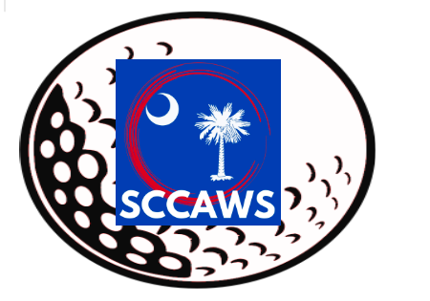
The South Carolina
Coaches Association of
Women’s Sports
Golf Tournament
June 12, 2023
Ponderosa Country Club, Batesburg-Leesville
Hole Sponsorship - $100
There will be an advertisement for your sponsorship on the tee box of each hole you sponsor.
Hole sponsorships will also receive advertisement in the SCCAWS All-Star Volleyball & Softball Programs.
Date:
Hole Sponsor/Business:
Contact Name:
Address:
Phone: Email:
Check MUST accompany the Sponsorship Form.
Make check payable to: SCCAWS
Return form and check to: Nicole Amick
208 Rabun Street
Batesburg, SC 29006
To guarantee advertisement, we must receive form by May 29, 2023
For more information, please contact:
Shea Hall 864-980-0525 Nicole Amick 803-917-7364 Amy Boozer 803-240-5795 Jackie Shealy 803-260-2521 Warren Coker 843-687-8867 Michelle Yeater 803-215-9422 Alexis Glover 843-425-0633

