South Carolina Coaches Association of Women’s Sports
18th Annual Golf Tournament
June 12, 2023
10:00AM Shotgun Start
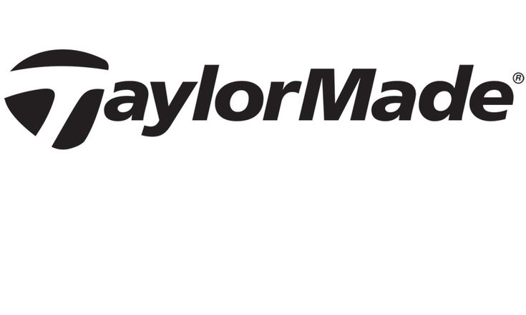
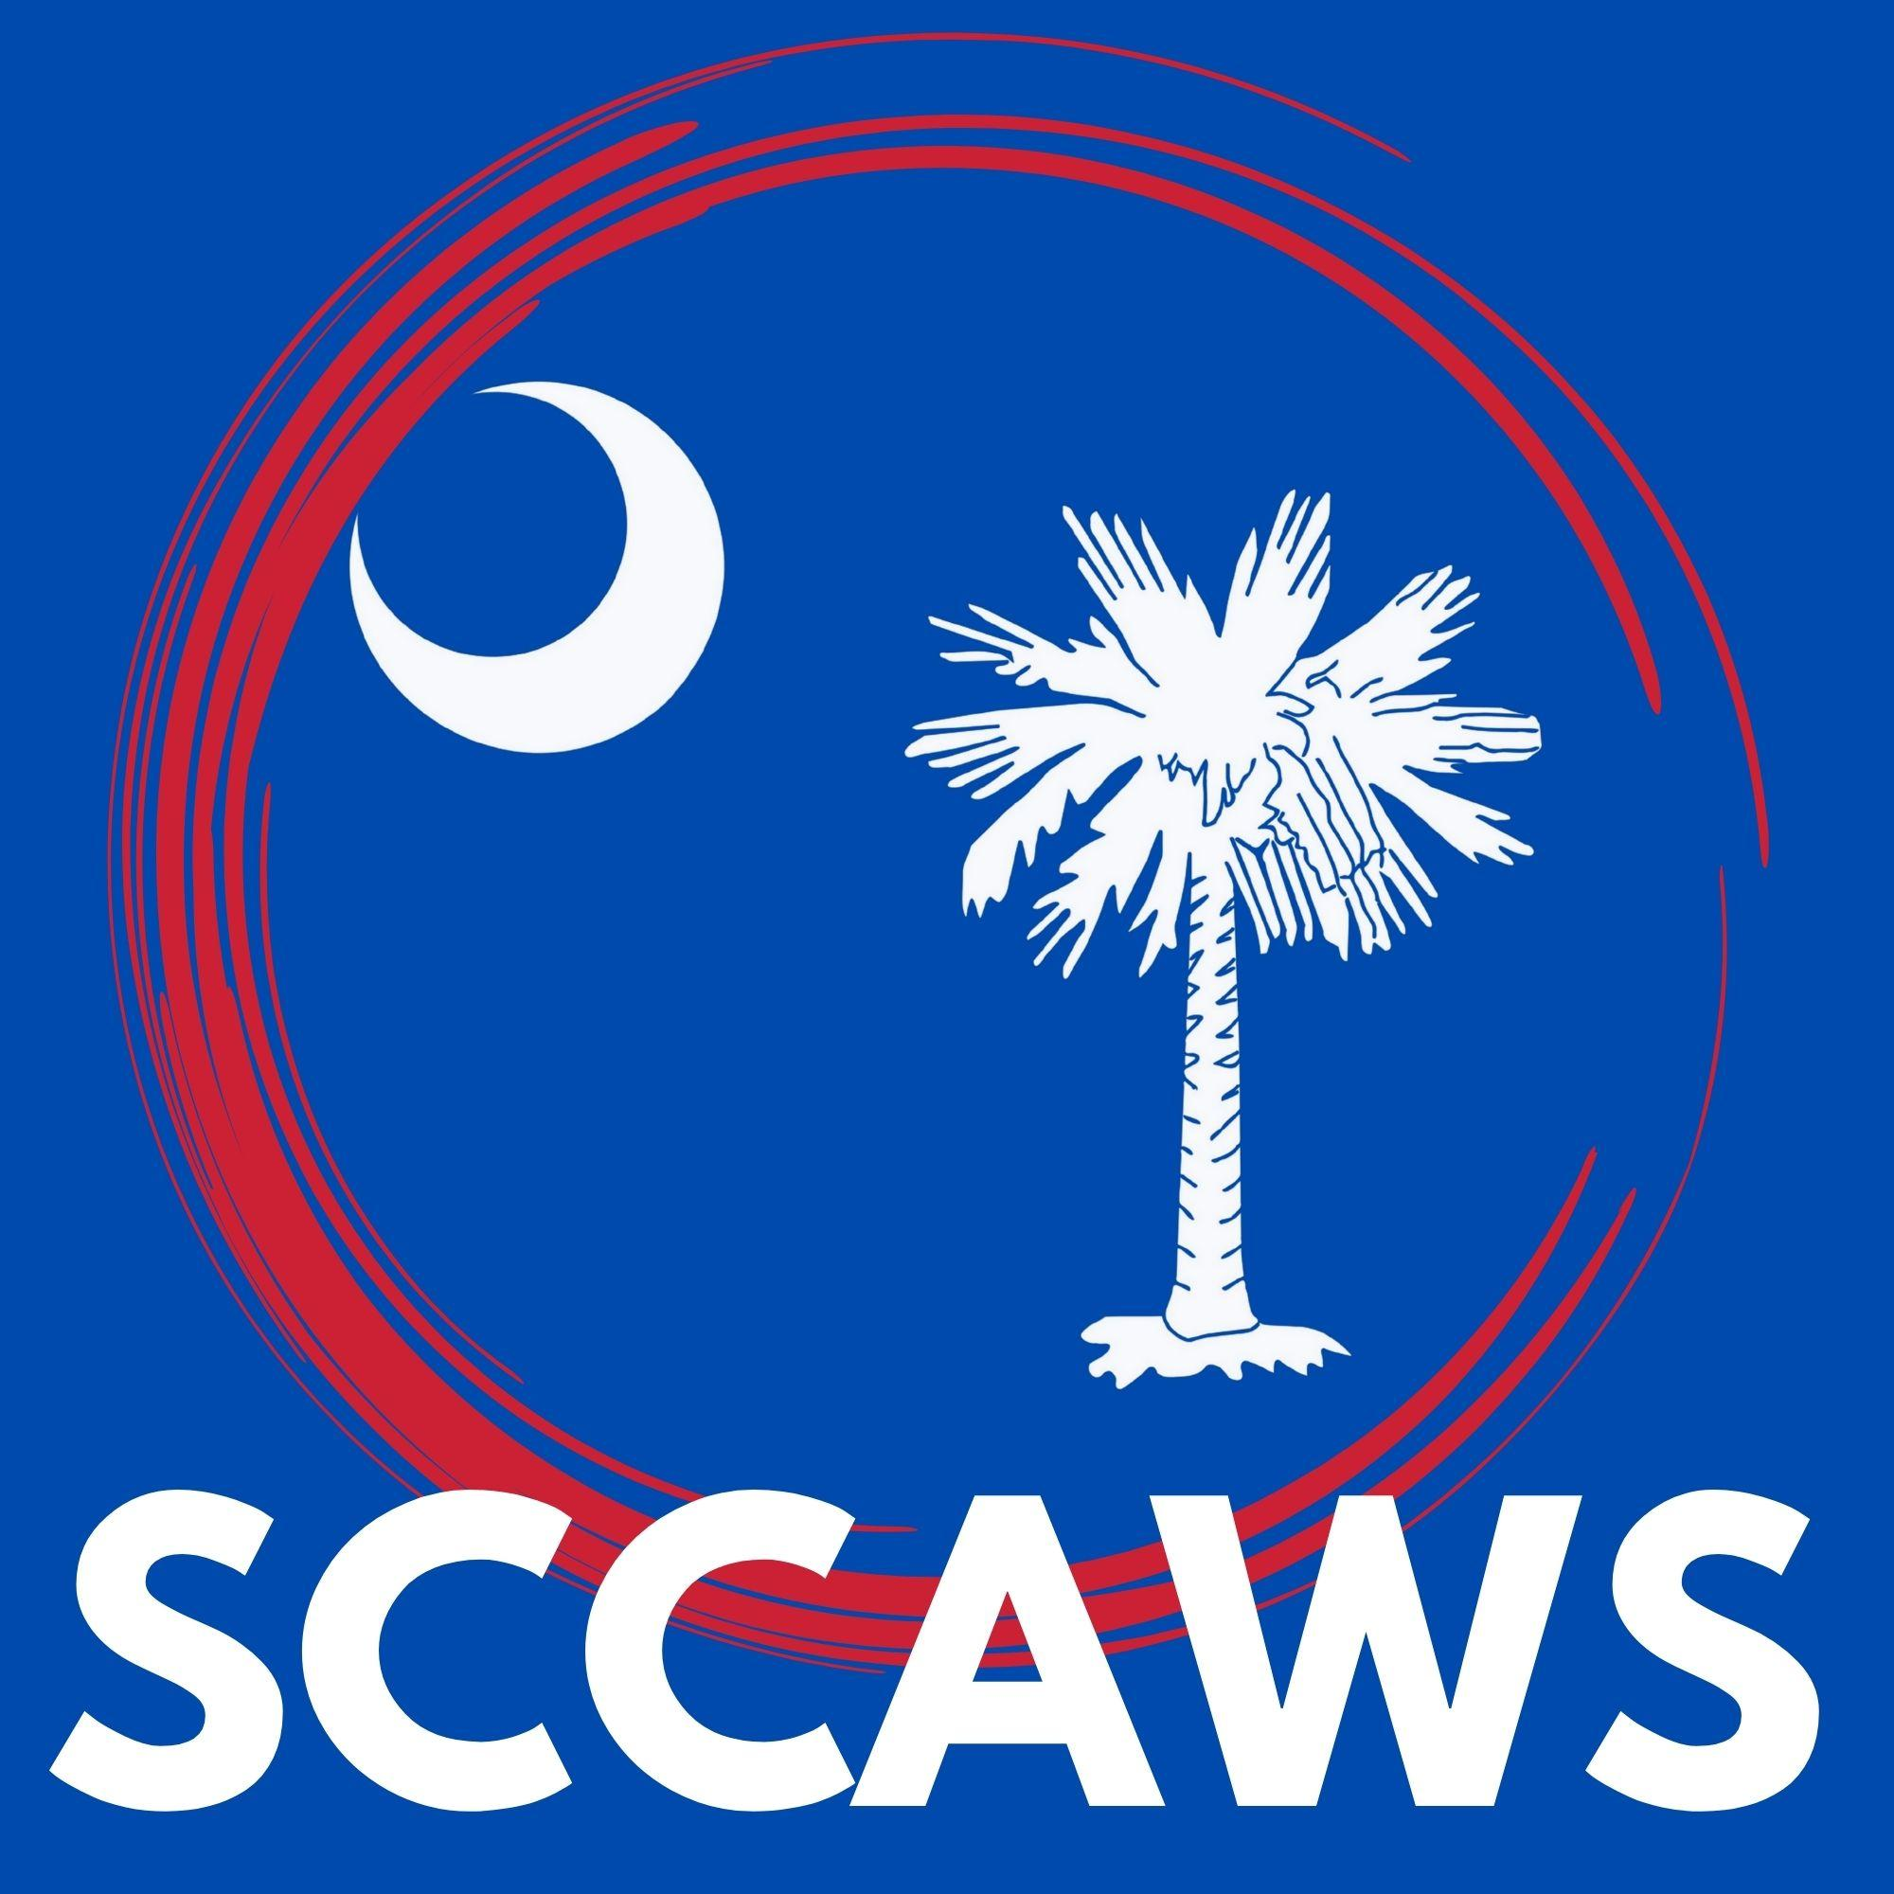

$60 per player
OR
$240 per team

190 Durango Drive
Batesburg-Leesville, SC 29070
(803) 532-3472

First, Second & Third Place teams receive cash & trophies
BBQ Lunch & Beverages will be provided

For more Information Please Contact:
Shea Hall 864-980-0525 Nicole Amick 803-917-7364 Amy Boozer 803-240-5795 Jackie Shealy 803-260-2521
To enter, make a check payable to SCCAWS.
$20 HACKER SPECIAL
2 mulligans
Red Tee for men
*women 1 extra throw
1 Throw
Complete the form below and mail to:
PACKAGE #1
Mulligans and Throws for sale, 2 per player $5 each
Nicole Amick,
208 Rabun Street, Batesburg, SC
29006

Name: | Team Name:
Name: | Contact Person:
Name: | Phone Number:
Name: | Email:

